EX:NO:4 STOCK MAINTENANCE SYSTEM
Use case:
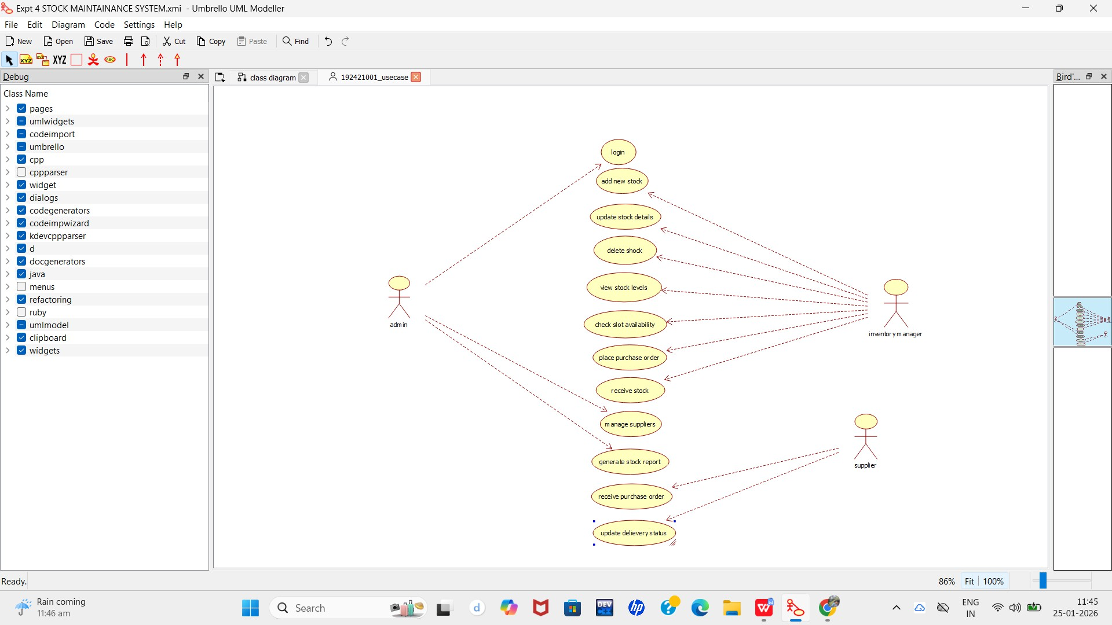
class diagram

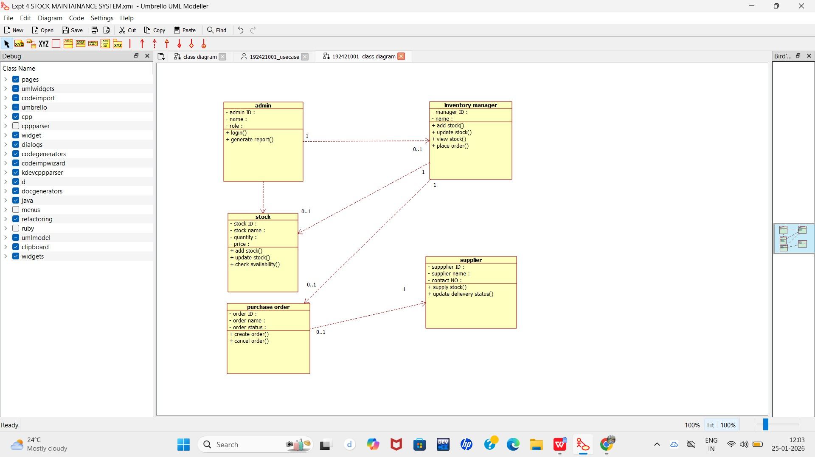

ACTIVITY DIAGRAM:

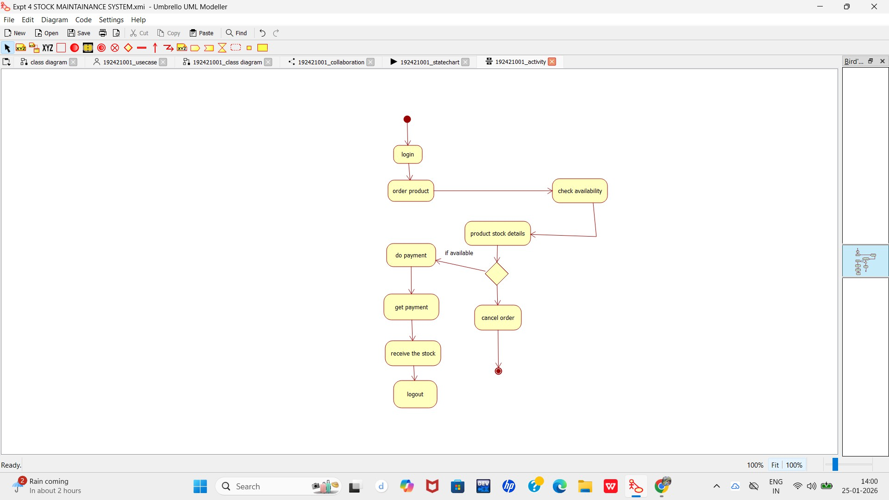

SEQUENCE DIAGRAM:

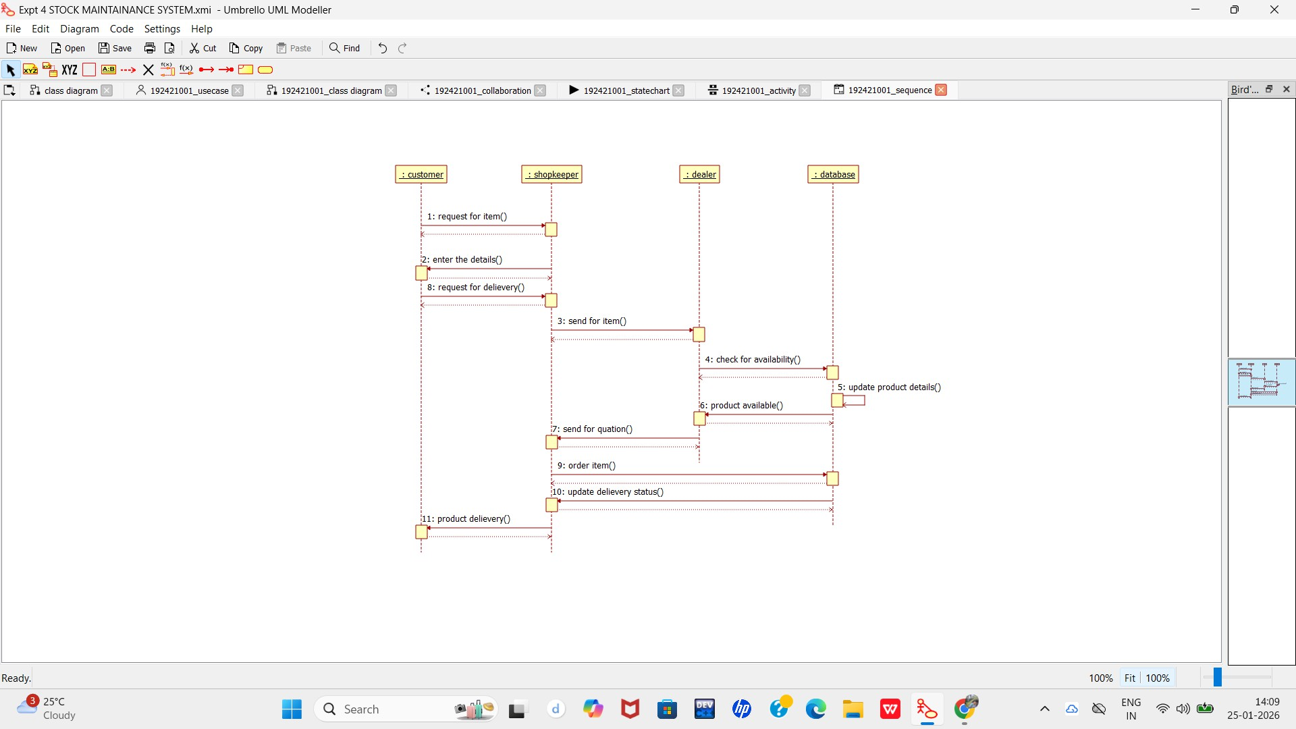

COLLABORATION DIAGRAM:

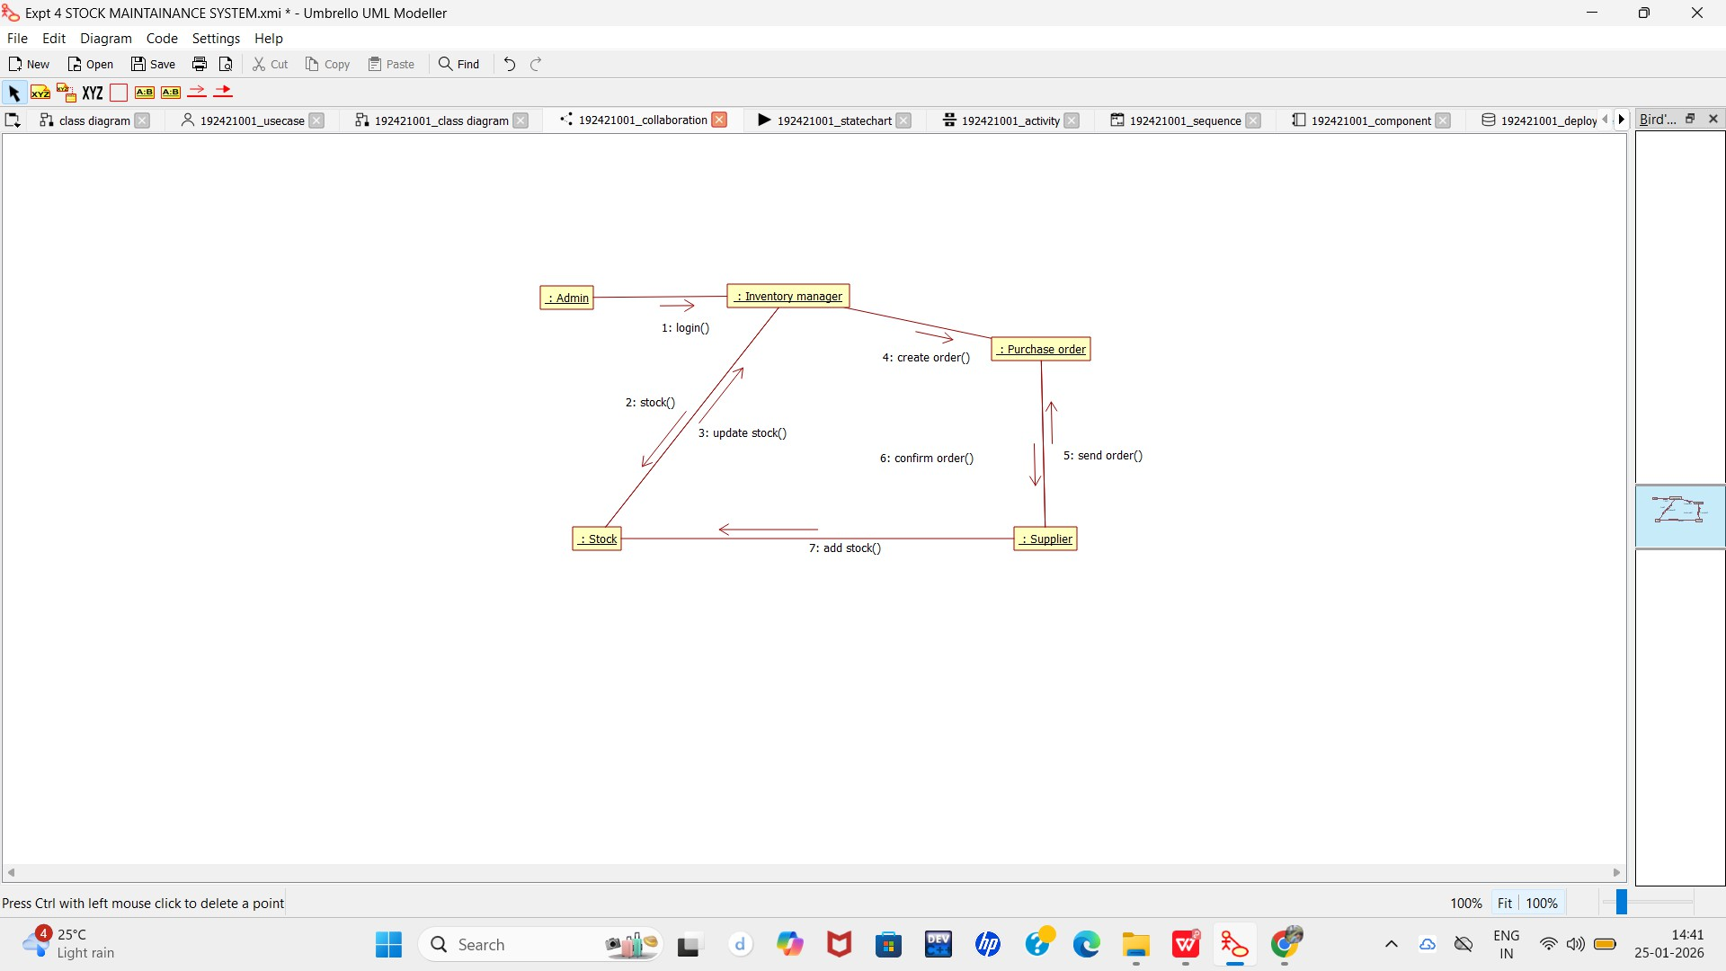

STATE CHART DIAGRAM:

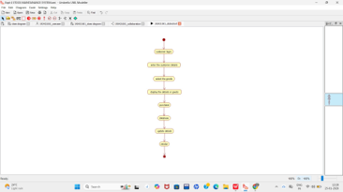

COMPONENT DIAGRAM:
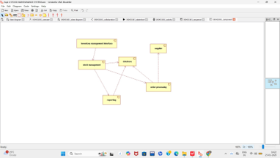

DEPLOYMENT DIAGRAM:

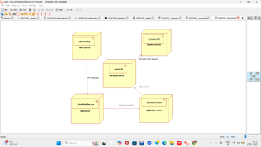

PACKAGE DIAGRAM:

